**Using search fields in Asset Module**

Lowercase entered in Status field.

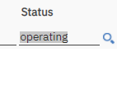

Uppercase entered in Status field.

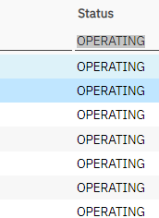

Selecting operating from search field.

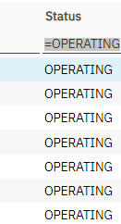

Lowercase in another search field

