Symptom code is the Problem Code. It was empty, I added and saved the workorder. If leave it empty, it works fine, and if I add it, and exit the app and reload the workorder, it works fine.
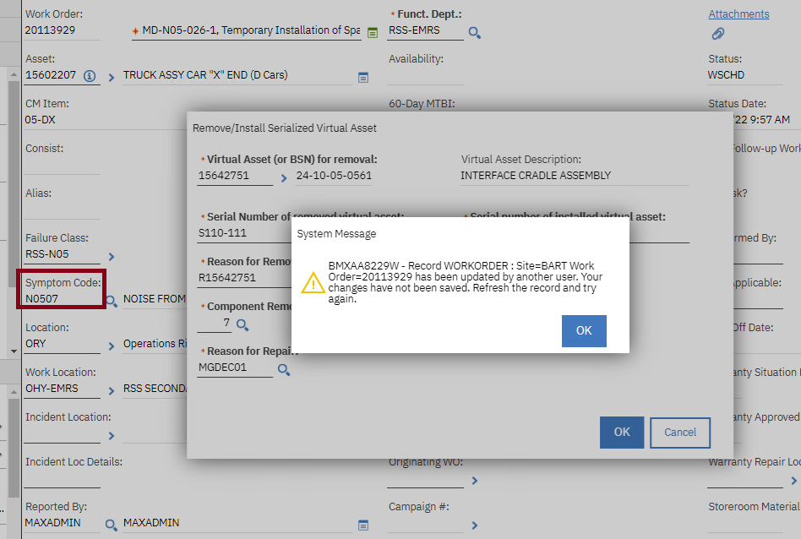

11 May 2023 09:28:03:645 [ERROR] [UAT3761UI4] [] Error from script REMOVEVIRTUALASSET launchPointName: REMOVEVIRTUALASSET
11 May 2023 09:28:03:654 [ERROR] [UAT3761UI4] [] BMXAA8229W - Record WORKORDER : Site=BART Work Order=20113929 has been updated by another user. Your changes have not been saved. Refresh the record and try again.
psdi.util.MXRowUpdateException: BMXAA8229W - Record WORKORDER : Site=BART Work Order=20113929 has been updated by another user. Your changes have not been saved. Refresh the record and try again.
at psdi.mbo.MboSet.updateMbo(MboSet.java:9332)
at psdi.app.workorder.WOSet.updateMbo(WOSet.java:1507)
at psdi.mbo.MboSet.saveTransaction(MboSet.java:7743)
at psdi.txn.MXTransactionImpl.saveTransaction(MXTransactionImpl.java:221)
at psdi.txn.MXTransactionImpl.save(MXTransactionImpl.java:156)
at psdi.mbo.MboSet.save(MboSet.java:7540)
at psdi.mbo.MboSet.save(MboSet.java:7464)
at psdi.app.workorder.WOSet.save(WOSet.java:1484)
at sun.reflect.NativeMethodAccessorImpl.invoke0(Native Method)
at sun.reflect.NativeMethodAccessorImpl.invoke(NativeMethodAccessorImpl.java:90)
at sun.reflect.DelegatingMethodAccessorImpl.invoke(DelegatingMethodAccessorImpl.java:55)
at java.lang.reflect.Method.invoke(Method.java:508)
at org.python.core.PyReflectedFunction.__call__(PyReflectedFunction.java:188)
at org.python.core.PyReflectedFunction.__call__(PyReflectedFunction.java:206)
at org.python.core.PyObject.__call__(PyObject.java:480)
at org.python.core.PyObject.__call__(PyObject.java:484)
at org.python.core.PyMethod.__call__(PyMethod.java:126)
at org.python.pycode._pyx576.f$0(<script>:162)
at org.python.pycode._pyx576.call_function(<script>)
at org.python.core.PyTableCode.call(PyTableCode.java:171)
at org.python.core.PyCode.call(PyCode.java:18)
at org.python.core.Py.runCode(Py.java:1614)
at org.python.core.__builtin__.eval(__builtin__.java:497)
at org.python.core.__builtin__.eval(__builtin__.java:501)
at org.python.util.PythonInterpreter.eval(PythonInterpreter.java:259)
at org.python.jsr223.PyScriptEngine.eval(PyScriptEngine.java:57)
at org.python.jsr223.PyScriptEngine.access$300(PyScriptEngine.java:20)
at org.python.jsr223.PyScriptEngine$PyCompiledScript.eval(PyScriptEngine.java:250)
at com.ibm.tivoli.maximo.script.JSR223ScriptDriver.evalScript(JSR223ScriptDriver.java:275)
at com.ibm.tivoli.maximo.script.AbstractScriptDriver.runScript(AbstractScriptDriver.java:155)
at com.ibm.tivoli.maximo.script.ScriptAction.applyCustomAction(ScriptAction.java:108)
at psdi.common.action.Action.executeCustomClass(Action.java:399)
at psdi.common.action.Action.executeAction(Action.java:311)
at psdi.common.action.Action.executeAction(Action.java:344)
at psdi.webclient.system.controller.SystemEventHandler.WFACTION(SystemEventHandler.java:1610)
at sun.reflect.NativeMethodAccessorImpl.invoke0(Native Method)
at sun.reflect.NativeMethodAccessorImpl.invoke(NativeMethodAccessorImpl.java:90)
at sun.reflect.DelegatingMethodAccessorImpl.invoke(DelegatingMethodAccessorImpl.java:55)
at java.lang.reflect.Method.invoke(Method.java:508)
at psdi.webclient.system.controller.BaseInstance.handleEvent(BaseInstance.java:431)
at psdi.webclient.system.controller.BaseInstance.handleEvent(BaseInstance.java:425)
at psdi.webclient.system.session.WebClientSession.handleEvent(WebClientSession.java:1348)
at psdi.webclient.system.session.WebClientSession.processRequestEvent(WebClientSession.java:6219)
at psdi.webclient.system.session.WebClientSession.handleClientSideQueueRequest(WebClientSession.java:6175)
at psdi.webclient.system.session.WebClientSession.handleRequest(WebClientSession.java:892)
at psdi.webclient.system.session.AsyncRequestManager.handleRequest(AsyncRequestManager.java:555)
at psdi.webclient.system.session.AsyncRequestManager.manageRequest(AsyncRequestManager.java:253)
at psdi.webclient.system.controller.RequestManager.manageRequest(RequestManager.java:290)
at psdi.webclient.servlet.WebClientServlet.handleRequest(WebClientServlet.java:141)
at psdi.webclient.servlet.WebClientServlet.doPost(WebClientServlet.java:52)
at javax.servlet.http.HttpServlet.service(HttpServlet.java:707)
at javax.servlet.http.HttpServlet.service(HttpServlet.java:790)
at com.ibm.ws.webcontainer.servlet.ServletWrapper.service(ServletWrapper.java:1235)
at com.ibm.ws.webcontainer.servlet.ServletWrapper.handleRequest(ServletWrapper.java:779)
at com.ibm.ws.webcontainer.servlet.ServletWrapper.handleRequest(ServletWrapper.java:478)
at com.ibm.ws.webcontainer.servlet.ServletWrapperImpl.handleRequest(ServletWrapperImpl.java:178)
at com.ibm.ws.webcontainer.filter.WebAppFilterChain.invokeTarget(WebAppFilterChain.java:143)
at com.ibm.ws.webcontainer.filter.WebAppFilterChain.doFilter(WebAppFilterChain.java:96)
at psdi.webclient.system.filter.HttpCrossSiteScriptingSecurity.doFilter(HttpCrossSiteScriptingSecurity.java:66)
at com.ibm.ws.webcontainer.filter.FilterInstanceWrapper.doFilter(FilterInstanceWrapper.java:197)
at com.ibm.ws.webcontainer.filter.WebAppFilterChain.doFilter(WebAppFilterChain.java:90)
at psdi.webclient.system.filter.MXCorrelationFilter.doFilter(MXCorrelationFilter.java:137)
at com.ibm.ws.webcontainer.filter.FilterInstanceWrapper.doFilter(FilterInstanceWrapper.java:197)
at com.ibm.ws.webcontainer.filter.WebAppFilterChain.doFilter(WebAppFilterChain.java:90)
at psdi.webclient.system.filter.PerformanceMonitor.doFilter(PerformanceMonitor.java:126)
at com.ibm.ws.webcontainer.filter.FilterInstanceWrapper.doFilter(FilterInstanceWrapper.java:197)
at com.ibm.ws.webcontainer.filter.WebAppFilterChain.doFilter(WebAppFilterChain.java:90)
at psdi.webclient.system.filter.HttpXFrameOptionsFilter.doFilter(HttpXFrameOptionsFilter.java:38)
at com.ibm.ws.webcontainer.filter.FilterInstanceWrapper.doFilter(FilterInstanceWrapper.java:197)
at com.ibm.ws.webcontainer.filter.WebAppFilterChain.doFilter(WebAppFilterChain.java:90)
at psdi.webclient.system.filter.MTContextFilter.doFilter(MTContextFilter.java:53)
at com.ibm.ws.webcontainer.filter.FilterInstanceWrapper.doFilter(FilterInstanceWrapper.java:197)
at com.ibm.ws.webcontainer.filter.WebAppFilterChain.doFilter(WebAppFilterChain.java:90)
at com.ibm.ws.webcontainer.filter.WebAppFilterManager.doFilter(WebAppFilterManager.java:969)
at com.ibm.ws.webcontainer.filter.WebAppFilterManager.invokeFilters(WebAppFilterManager.java:1109)
at com.ibm.ws.webcontainer.webapp.WebApp.handleRequest(WebApp.java:4217)
at com.ibm.ws.webcontainer.webapp.WebAppImpl.handleRequest(WebAppImpl.java:2208)
at com.ibm.ws.webcontainer.webapp.WebGroup.handleRequest(WebGroup.java:304)
at com.ibm.ws.webcontainer.WebContainer.handleRequest(WebContainer.java:1030)
at com.ibm.ws.webcontainer.WSWebContainer.handleRequest(WSWebContainer.java:1817)
at com.ibm.ws.webcontainer.channel.WCChannelLink.ready(WCChannelLink.java:382)
at com.ibm.ws.http.channel.inbound.impl.HttpInboundLink.handleDiscrimination(HttpInboundLink.java:465)
at com.ibm.ws.http.channel.inbound.impl.HttpInboundLink.handleNewRequest(HttpInboundLink.java:532)
at com.ibm.ws.http.channel.inbound.impl.HttpInboundLink.processRequest(HttpInboundLink.java:318)
at com.ibm.ws.http.channel.inbound.impl.HttpICLReadCallback.complete(HttpICLReadCallback.java:88)
at com.ibm.ws.ssl.channel.impl.SSLReadServiceContext$SSLReadCompletedCallback.complete(SSLReadServiceContext.java:1833)
at com.ibm.ws.tcp.channel.impl.AioReadCompletionListener.futureCompleted(AioReadCompletionListener.java:175)
at com.ibm.io.async.AbstractAsyncFuture.invokeCallback(AbstractAsyncFuture.java:217)
at com.ibm.io.async.AsyncChannelFuture.fireCompletionActions(AsyncChannelFuture.java:161)
at com.ibm.io.async.AsyncFuture.completed(AsyncFuture.java:138)
at com.ibm.io.async.ResultHandler.complete(ResultHandler.java:204)
at com.ibm.io.async.ResultHandler.runEventProcessingLoop(ResultHandler.java:775)
at com.ibm.io.async.ResultHandler$2.run(ResultHandler.java:905)
at com.ibm.ws.util.ThreadPool$Worker.run(ThreadPool.java:1909)

