IBM Support

Email Interaction Setup using Workflow
Troubleshooting
Problem
Users need to interact with Maximo Workflow using a smart phone
Resolving The Problem
1) Adjust the communication templates

Go to the MFMAILSENDWFA1, MFMAILRESCOMPWF, and MFMAILRESREJWF1 templates
In the "Send from" field, specify the address of the E-mail Listener.
Listener: MCCO_MaximoSupport@grableservices.com
MFMAILSENDWFA1: MFMAILSENDWFA1_J
MFMAILRESCOMPWF: MFMAILRESAPPRWF
MFMAILRESREJWF1: MFMAILRESREJWF1_

2) Attach a Role and a Communication Template to Workflow Assignment

In the Workflow Designer application, open the task node properties
In the Communication template field, specify MFMAILSENDWFA1 communication template.
MFMAILSENDWFA1 is an out of the box template for the first email that is sent to the user when a new record is created.
Role: JBPR_APPR
MFMAILSENDWFA1: MFMAILSENDWFA1_J

3) Configure the MFMAILSENDWFM Escalation

Modify the SQL query in the escalation to specify the workflow process that sends the first email. Change the wfname in the SQL to an appropriate workflow process name.
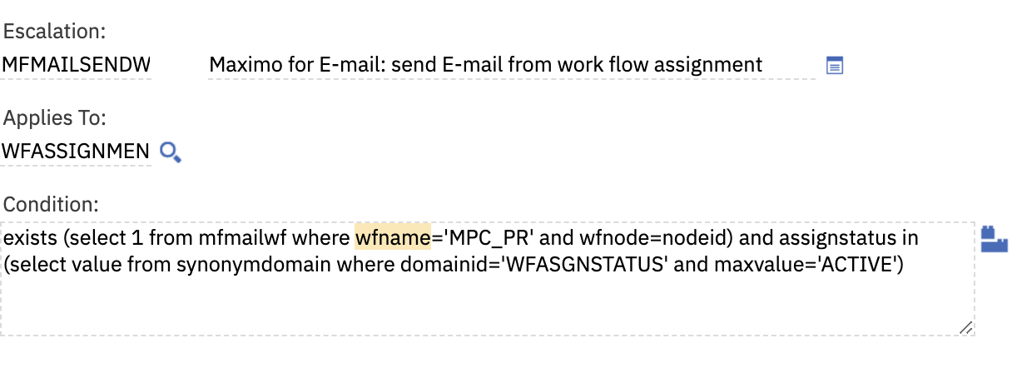
MFMAILSENDPR_JB
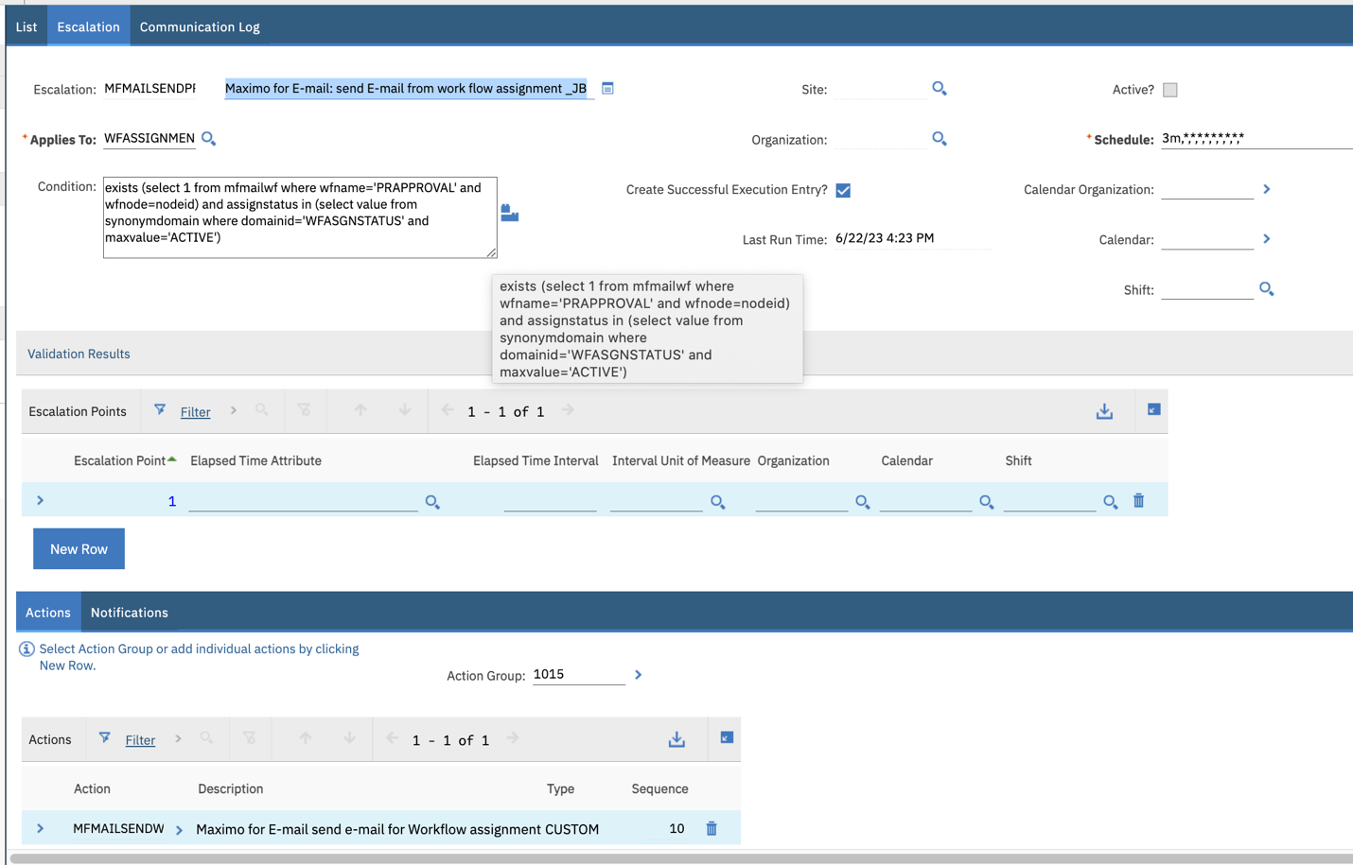

4) Configure the Email Listener
In the E-mail Listener application, create a new record.
Enter MFMAILRCV in the workflow process field.
Cron Task Name = LSNRCRON
NOTE: Crontask instance needs to be active for the LSNRCRON cron task in the Cron Task Setup application

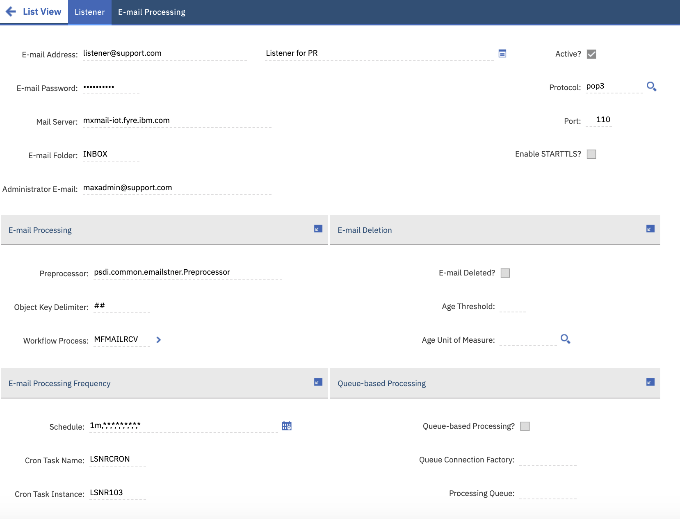

Select "Security Settings" action and add the Maximo Business Object (MBO) and Application name that you want to Interact with. For examples, PR,ASSET,WORKORDER objects
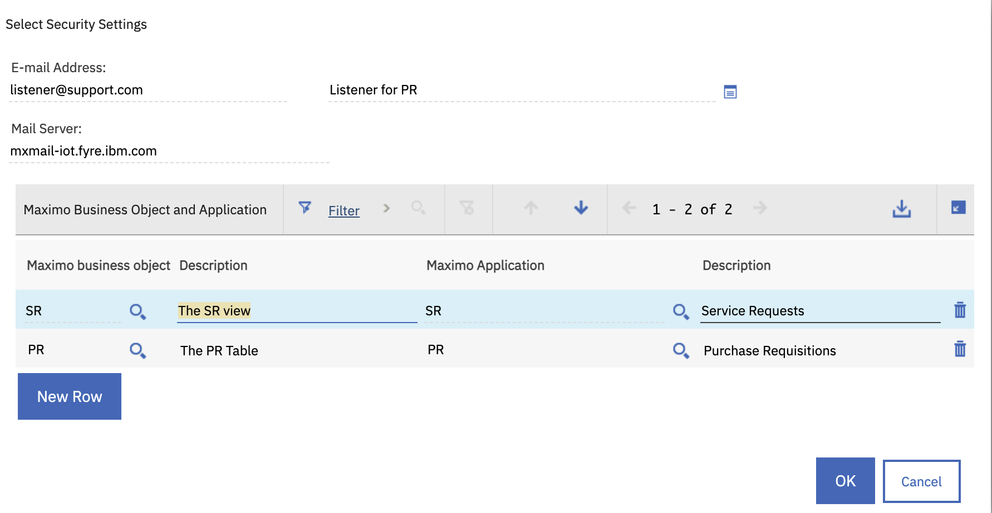
Activate the email listener
Activate the MFMAILCLEAN cron task in Cron Task Setup application

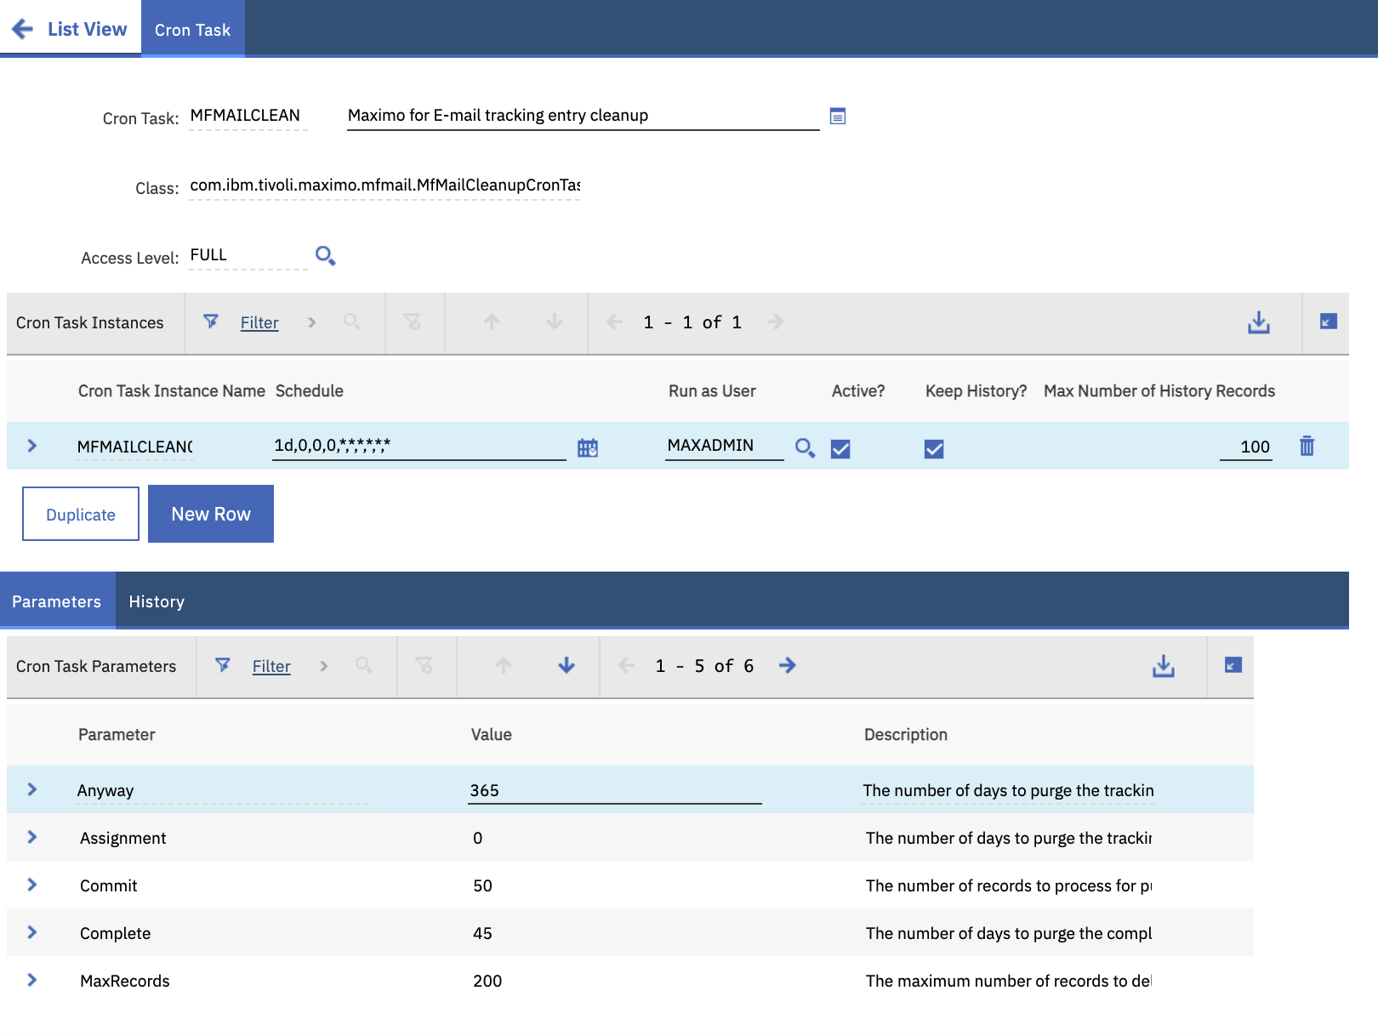
5) Configure the Email Interactions
Make a duplicate of any existing Communication Template. For example,MFMAILRESCOMPPR communication template
Enter an object in the "Applies To" field. For example, PR object
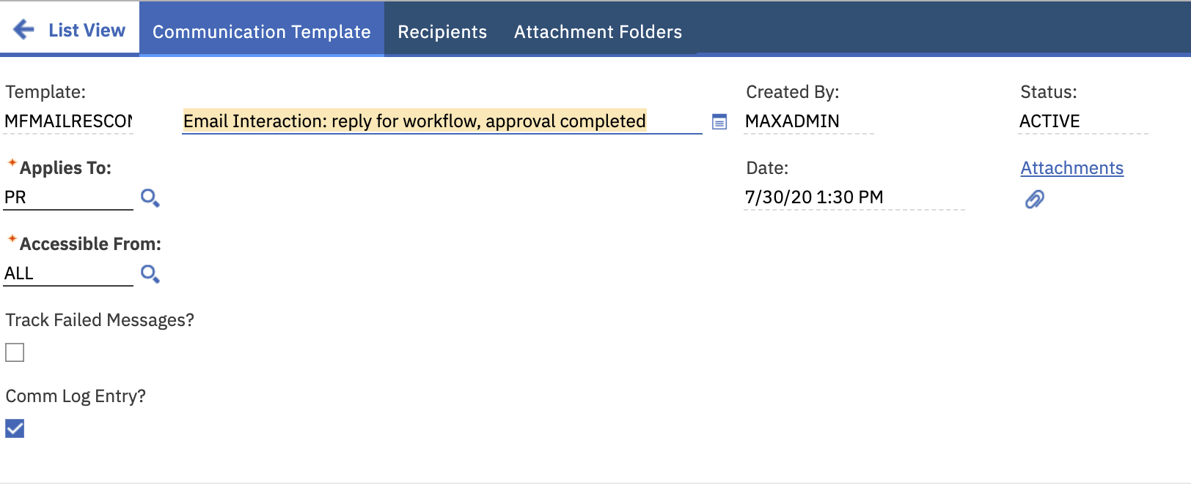
Go to Email Interaction Setup application and create a new record

Enter a Target Object.For example, workorder or PR object
Enter a workflow process

Enter a node in the Workflow Assignment Configuration
Attach MFMAILRESCOMPPR Communication template.

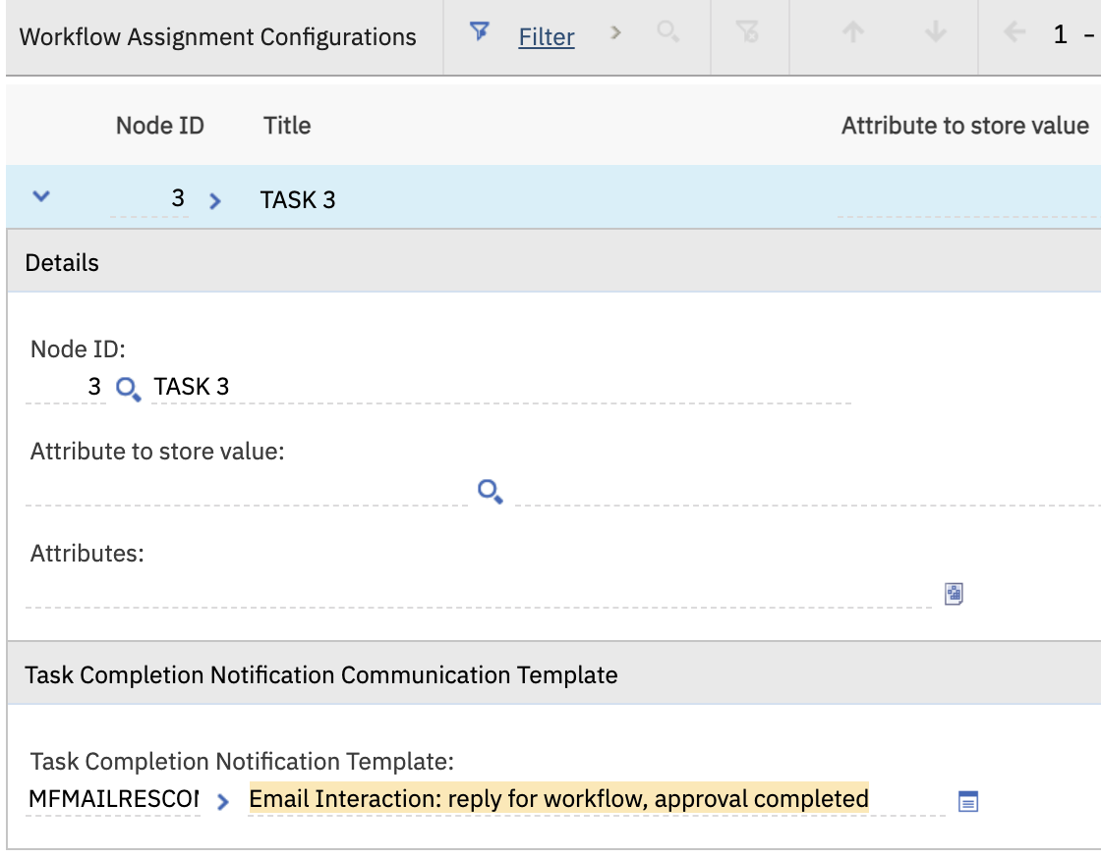

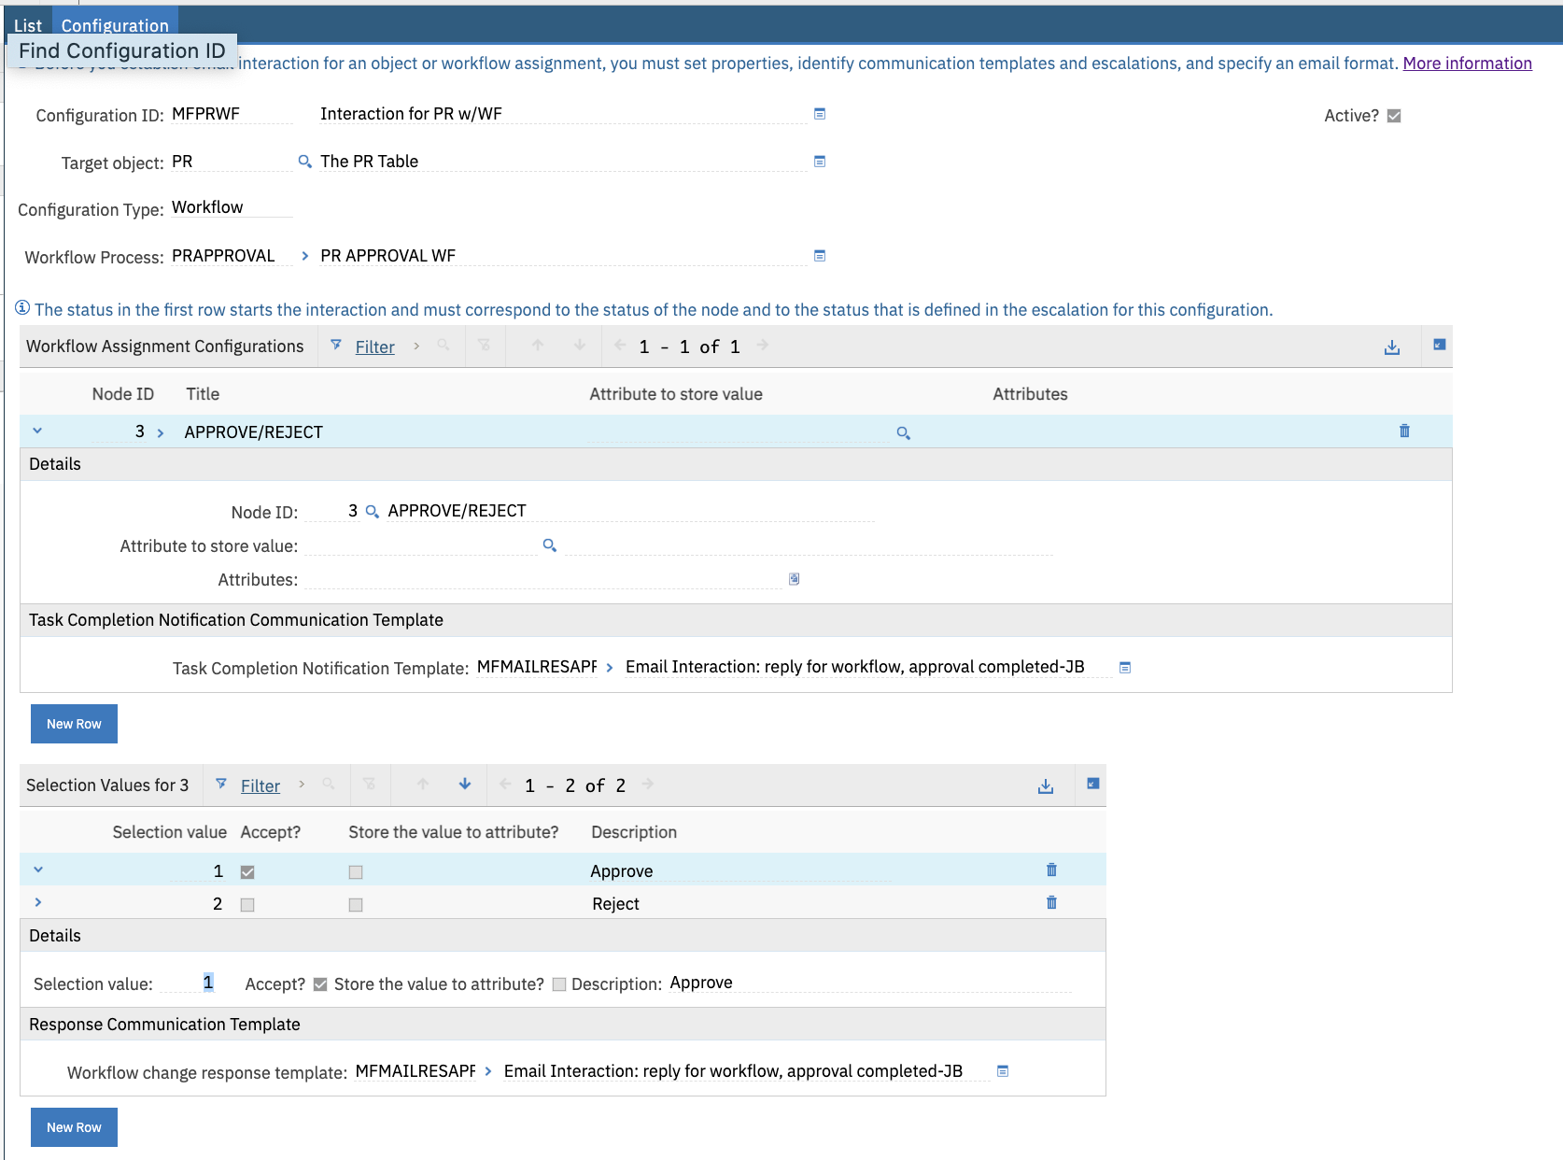

6) Make sure user email type is set to 1 (Simple Format)
Go to the People application.
Set "Email Format" to 1 for all the Users.

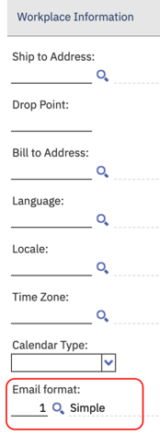

7) Build a Workflow process in Workflow Designer to reinforce a business process

Create a Workflow process in Workflow Designer application
New work order records will go to Financial Approval 1.
If the estimated labor cost is greater than $500, then it will go to Financial Approver 2.
Then someone will perform some safety check
Enable and activate the workflow.
Option: select "Set Process to Auto-initiate" action if you wish to start the workflow automatically when user creates a new record

Use Case

1)Create a new work order in Work Order Tracking application
Click the Route Workflow icon

2) User wilson receives email in his inbox

Email offers two options:
Option 1 - I approve this work order. Route to next step in workflow
Option 2 - Cancel this work order

My e-mail template:

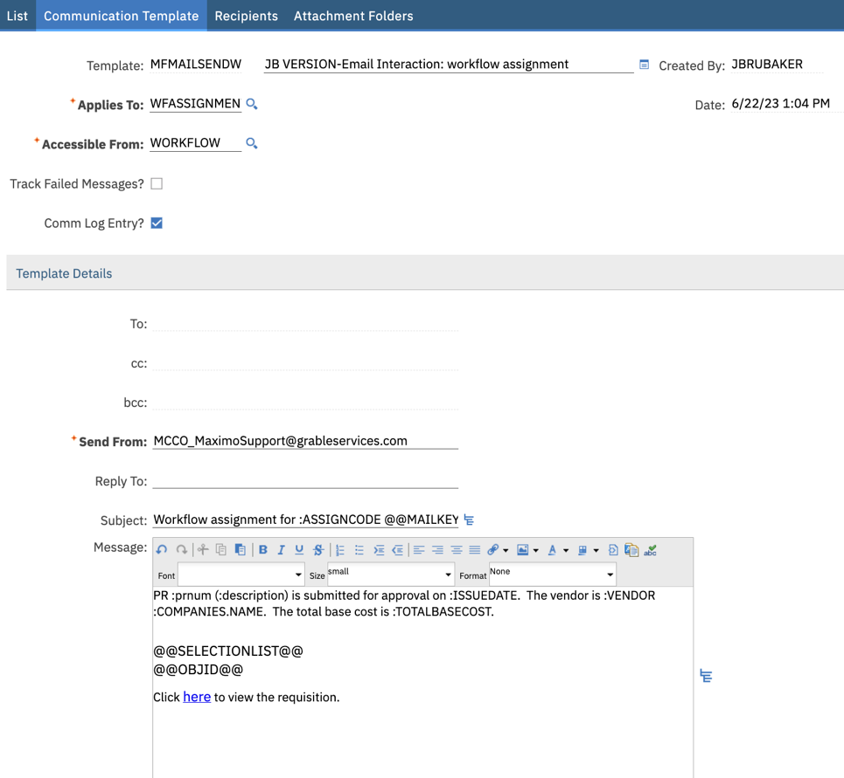

Here is what I am receiving in my e-mail.

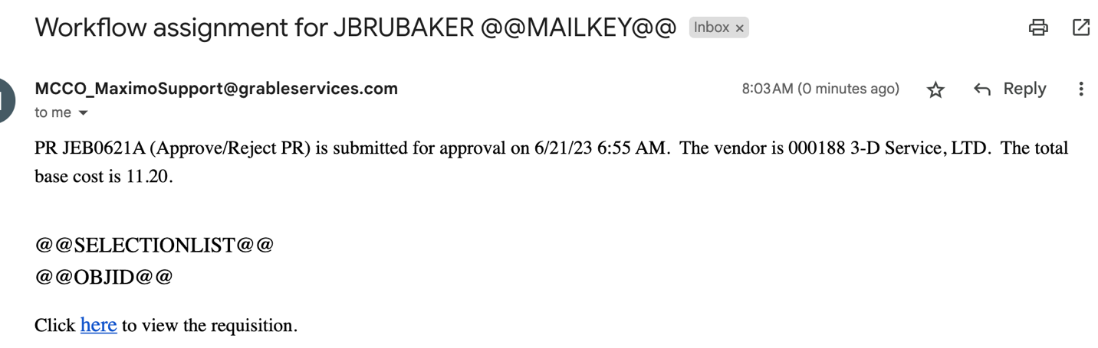

How does the @@SELECTIONLIST@@ actually work? Please provide DETAILED screenshots of the actual setup for a purchase request.

